Catalysis with Nanoparticles supported by Cellulose Nanocrystals and plasmonic Nanoparticles
Audrey Moores, Centre for Green Chemistry and Catalysis, McGill University, 801 Sherbrooke St. West, Montreal, QC, Canada, H3A-0B8
We explored the use of cellulose nanocrystals as a non-innocent support to generate metal/cellulose nanohybrids, useful to catalysis.¹ We showed that palladium could be easily deposited onto CNC under mild H₂ pressures and afford active hydrogenation catalysts.² Interestingly, the hydrogenation of prochiral ketones in water at room temperature and 4 bars H₂ was performed with this catalysts. This system, where CNCs act as support and sole chiral source,
achieves an ee of 65% with 100% conversions.³ With Ru, extremely active and recyclable catalysts were accessed for the difficult reduction of arenes under mild conditions.⁴ These nanocrystals in suspension could allow the direct synthesis of silver nanoparticles without the use of any additional oxidizing or reducing chemical.⁵

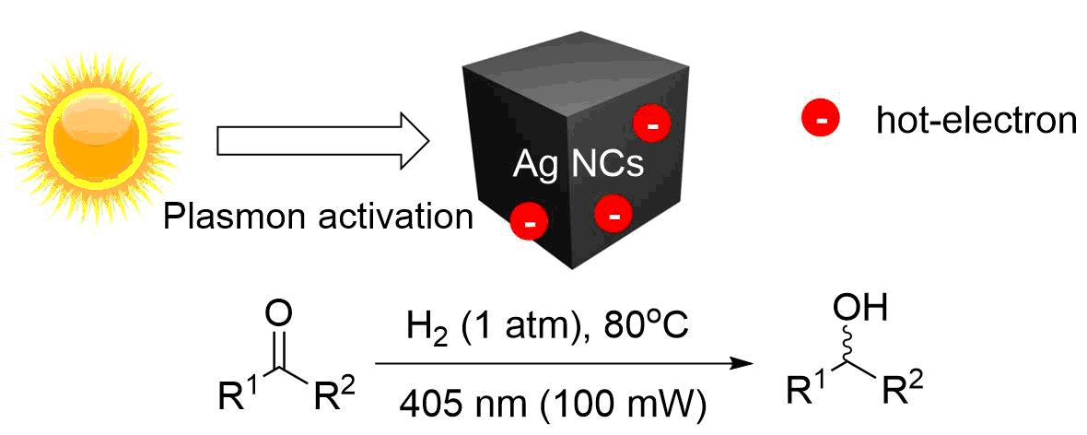
Besides, we have employed silver nanocubes for hydrogen activation and hydrogenation of ketones and aldehydes via irradiation at 405 nm, corresponding to the position of the plasmon band of the nanocubes.⁶ Exposure to other wavelengths, or absence of light failed to provide activity thus proving the plasmonic effect. Compared to other catalytic systems, the plasmonically activated catalyst provides access to primary and secondary alcohols using milder conditions, in a highly atom economical fashion. Plasmonic catalysis of the oxidation of aldehyde to carboxylic acid was also demonstrated.

1. M. Kaushik and A. Moores, Green Chem. , 2016, 18, 622-637.
2. C. M. Cirtiu, A. F. Dunlop-Briere and A. Moores, Green Chem., 2011, 13, 288-291.
3. M. Kaushik, K. Basu, C. Benoit, C. M. Cirtiu, H. Vali and A. Moores, J. Am. Chem. Soc., 2015.
4. M. Kaushik, H. M. Friedman, M. Bateman and A. Moores, RSC Adv., 2015, 5, 53207-53210.
5. M. Kaushik, A. Y. Li, R. Hudson, M. Masnadi, C.-J. Li and A. Moores, Green Chem., 2016, 18, 129-133.
6. M. Landry, A. Gellé, B. Y. Meng, C. J. Barrett and A. Moores, ACS Catal., 2017, 7, 6128–6133.

