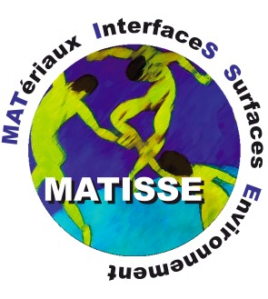

Applications are invited for a post-doctoral research associate position to work in the Growth and properties of hybrid thin film systems team (http://www.insp.upmc.fr/-Croissance-et-proprietes-de-.html) at the Institute of NanoSciences of Paris (INSP), at UPMC Sorbonne Universités. The applicant will work on a research project carried out in collaboration with the Mineralogy and magnetism with low dimensionality team (http://www.impmc.upmc.fr/en/research_teams/magnetic-mineralogy-in-low-dimensionality.html) of the Institut de minéralogie, de physique des matériaux et de cosmochimie (IMPMC). The aim of project is to develop and study new vertically aligned magnetic nanocomposites with enhanced uniaxial magnetic anisotropies.

In the framework of this project, the applicant will be implied in the growth of the systems, in their structural and magnetic characterization and in measurements campaign using x-ray magnetic circular dichroism at synchrotron facilities.

Applicants should have obtained a PhD in Physics before the starting date of the post-doc grant (1st October 2017). The ideal candidate will have an experimental background in the following fields: pulsed laser deposition, magnetometry, use of synchrotron-based spectroscopic techniques, electron microscopy, x-ray diffraction, magneto-optical measurements.

The applicant should be highly motivated with a demonstrated ability to work independently and with the skills to work well within a collaboration. The candidate should be pro-active and will be required to help supervise PhD and Masters students. Good problem solving skills as well as excellent oral and written communication skills, as demonstrated by writing papers and proposals, are required.

Fixed term: The funds for this position are available for 18 months in the first instance.

The expected starting date is the 1st October 2017.

Anticipated date for interviews: mid-June 2017

Applications, which should include a motivation letter, CV, full list of publications, and contact details of two referees, should be sent by e-mail to Dr. Franck Vidal (vidal@insp.jussieu.fr) before the 15th of June.

